Ho va ten : Pham Van Phuc

MSSV : 522H0068

Cau1

Source code :

public class Person {

protected String name;

protected int birthYear;

public Person() {

*this*.name = "";

*this*.birthYear = 0;

}

public Person(String *name*, int *year*) {

*this*.name = *name*;

*this*.birthYear = *year*;

}

public void setName(String *name*) {

*this*.name = *name*;

}

public String getName() {

return *this*.name;

}

public void setBYear(int *year*) {

*this*.birthYear = *year*;

}

public int getBirthYear() {

return *this*.birthYear;

}

public String toString() {

return "Name : " + *this*.name + ", Birth Year : " + *this*.birthYear;

}

}

public class Student extends Person {

private String ID;

private double score;

public Student() {

*super*();

*this*.ID = "";

*this*.score = 0;

}

public Student(String *name*, int *year*, String *ID*, double *score*) {

*super*(*name*, *year*);

*this*.ID = *ID*;

*this*.score = *score*;

}

public void setID(String *ID*) {

*this*.ID = *ID*;

}

public String getID() {

return *this*.ID;

}

public void setScore(int *score*) {

*this*.score = *score*;

}

public double getScore() {

return *this*.score;

}

public String toString() {

return *super*.toString() + ", ID :" + *this*.ID + ", Score :" + *this*.score;

}

}

public class Employee extends Person {

private String ID;

private double salary;

public Employee() {

*super*();

*this*.ID = "";

*this*.salary = 0;

}

public Employee(String *name*, int *birthYear*, String *ID*, double *salary*) {

*super*(*name*, *birthYear*);

*this*.ID = *ID*;

*this*.salary = *salary*;

}

public void setID(String *ID*) {

*this*.ID = *ID*;

}

public String getID() {

return *this*.ID;

}

public void setSalary(int *salary*) {

*this*.salary = *salary*;

}

public double getSalary() {

return *this*.salary;

}

public String toString() {

return *super*.toString() + ", ID :" + *this*.ID + ", Salary : " + *this*.salary;

}

}

import java.util.ArrayList;

public class PersonModel<*T*> {

private ArrayList<*T*> al = new ArrayList<*T*>();

public void add(*T* *obj*) {

al.add(*obj*);

}

public void display() {

for (*T* obj : al) {

System.out.println(obj);

}

}

public static void main(String *args*[]) {

System.out.println("522H0068 - Pham Van Phuc");

PersonModel<Student> studentModel = new PersonModel<Student>();

studentModel.add(new Student("John", 2000, "522H0091", 8.5));

studentModel.add(new Student("Sarah", 2005, " 522H0099", 9.2));

System.out.println("Students:");

studentModel.display();

PersonModel<Employee> employeeModel = new PersonModel<Employee>();

employeeModel.add(new Employee("Bob", 1992, "522H0068", 50000));

employeeModel.add(new Employee("Alice", 1990, " 522H0011", 40000));

System.out.println("Employees:");

employeeModel.display();

PersonModel<Person> personModel = new PersonModel<Person>();

personModel.add(new Person("Mary", 1989));

personModel.add(new Person("Tom", 1996));

System.out.println("People:");

personModel.display();

}

}

Man hinh chay

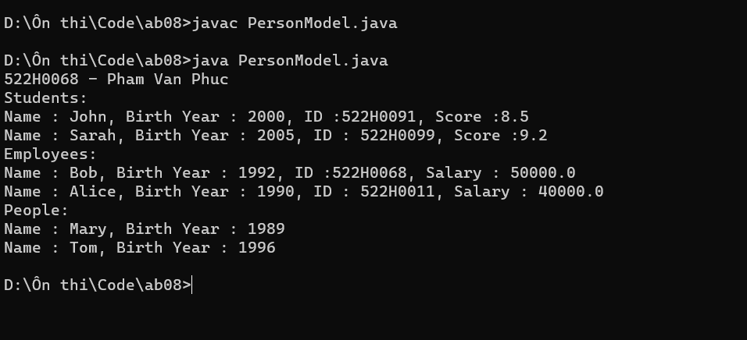

Cau 3

Code :

public abstract class Student {

protected String sName;

protected double gpa;

public Student(String *sName*, double *gpa*) {

*this*.sName = *sName*;

*this*.gpa = *gpa*;

}

public abstract String getRank();

public String toString() {

return "Student[" + "sName='" + sName + '\'' + ", gpa=" + gpa + ", rank='" + getRank() + '\'' + ']';

}

}

public class ITStudent extends Student {

private int sID;

public ITStudent(String *sName*, double *gpa*, int *sID*) {

*super*(*sName*, *gpa*);

*this*.sID = *sID*;

}

public String getRank() {

if (gpa <= 5) {

return "C";

} else if (gpa <= 8) {

return "B";

} else {

return "A";

}

}

public String toString() {

return *super*.toString() + ", SV IT, rank='" + getRank() + '\'' + ", sID=" + sID

+ ']';

}

}

public class MathStudent extends Student {

private String sID;

public MathStudent(String *sName*, double *gpa*, String *sID*) {

*super*(*sName*, *gpa*);

*this*.sID = *sID*;

}

public String getRank() {

if (gpa >= 5) {

return "Pass";

} else {

return "Fail";

}

}

public String toString() {

return *super*.toString() + ", SV Math, rank='" + getRank() + '\'' + ", sID='"

+ sID + '\'' + ']';

}

}

import java.util.ArrayList;

public class testStudent {

public static ArrayList<Student> findStudent(ArrayList<Student> *lstStu*) {

ArrayList<Student> result = new ArrayList<>();

for (Student student : *lstStu*) {

String rank = student.getRank();

if (rank.equals("A") || rank.equals("Pass")) {

result.add(student);

}

}

return result;

}

public static void main(String[] *args*) {

ArrayList<Student> students = new ArrayList<>();

students.add(new ITStudent("Phuc Pham", 9.5, 1234));

students.add(new MathStudent("Ngoc Dang", 6.0, "M123"));

students.add(new ITStudent("Minh Sang", 4.0, 5678));

students.add(new MathStudent("Sy Canh", 8.0, "M456"));

ArrayList<Student> result = findStudent(students);

for (Student student : result) {

System.out.println(student);

}

}

}

Man hinh chay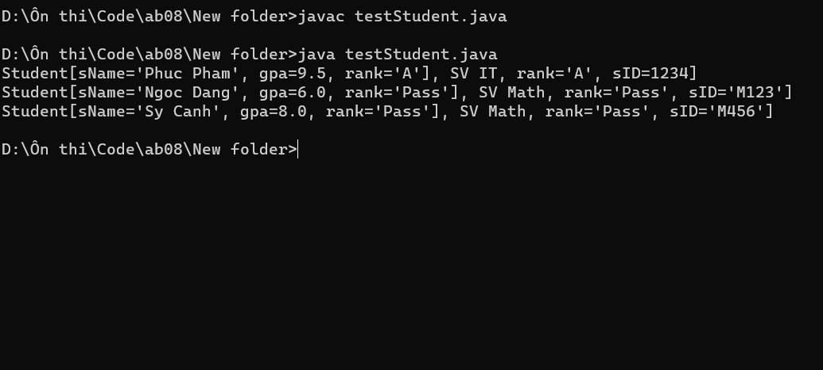

Cau 4

Source code :

import java.util.Scanner;

import java.util.Vector;

public class VectorExample {

public static void main(String[] *args*) {

Scanner input = new Scanner(System.in);

System.out.print("Nhap do dai cua vector X: ");

int n = input.nextInt();

Vector<Integer> X = new Vector<Integer>(n);

Vector<Integer> Y = new Vector<Integer>(n);

System.out.println("Nhap cac phan tu cua vector X:");

for (int i = 0; i < n; i++) {

int x = input.nextInt();

X.add(x);

}

for (int i = 0; i < n; i++) {

int x = X.get(i);

int y = 2 \* x \* x + 1;

Y.add(y);

}

System.out.println("Vector Y:");

for (int i = 0; i < n; i++) {

System.out.println(Y.get(i));

}

input.close();

}

}

Man hinh chay : 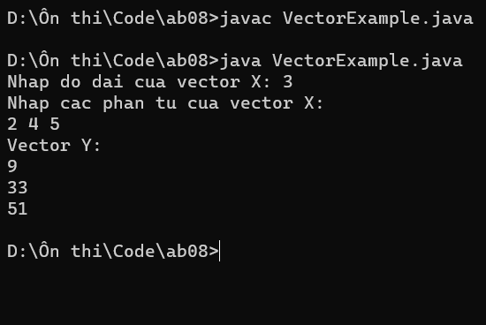

Cau 5 :

import java.util.HashMap;

import java.util.Scanner;

public class Tudien {

private HashMap<String, String> dictionary;

public Tudien() {

dictionary = new HashMap<String, String>();

dictionary.put("apple", "qua tao");

dictionary.put("banana", "qua chuoi");

dictionary.put("car", "o to");

dictionary.put("pen", "cay but");

dictionary.put("computer", "may tinh");

dictionary.put("rain", "mua");

dictionary.put("sun", "nang");

dictionary.put("dog", "con cho");

dictionary.put("house", "ngoi nha");

dictionary.put("tree", "cay coi");

}

public boolean containsWord(String *word*) {

return dictionary.containsKey(*word*.toLowerCase());

}

public String getMeaning(String *word*) {

return dictionary.get(*word*.toLowerCase());

}

public static void main(String[] *args*) {

Tudien dict = new Tudien();

Scanner scanner = new Scanner(System.in);

System.out.println("Nhap tu can tim nghia. Nhap \"exit\" de thoat ");

String input = scanner.nextLine();

while (!input.equals("exit")) {

if (dict.containsWord(input)) {

System.out.println(dict.getMeaning(input));

} else {

System.out.println("Khong tim thay ! ");

}

System.out.println("Nhap tu can tim nghia. Nhap \"exit\" de thoat");

input = scanner.nextLine();

}

scanner.close();

}

}

Man hinh chay :

